To: Our Local Businesses,
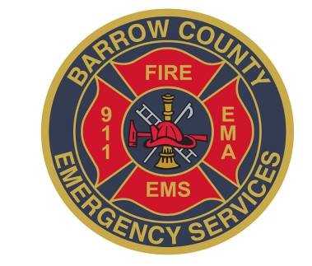
The Barrow County Fire Marshal’s Office is working to perform the annual fire and life safety inspections for businesses located in the county. We are sending this letter to notify the appropriate parties in order to ensure that you are prepared and to streamline the process. We are looking to ensure that the basic fire safety codes are being met in order to keep the public safe in their day to day activities. Below I have placed some of the common issues found during inspections. Any questions or concerns please let me know. My contact information can be found at the top of the page. Lastly, if you find that you are prepared please contact our office in order to set up a time and date for your inspection.
Barrow County Emergency Services
222
Pleasant Hill Church Road NE.

Tel: 770-307-2987 ext. 4996 Cell: 678-622-0342
Fax 770-307-3781
Chief Alan Shuman
www.barrowga.or
g

*Please see the following page for a list of the more common issues the Fire Marshal’s Office tends to encounter while doing business inspections.

- Missing or broken smoke alarms
- Exit signs/ emergency lighting missing or not working
- Clutter around electrical panel
- Fire extinguishers missing/out of date
- Exit ways cluttered or blocked
- Out of date business licenses
- Business licenses not posted in public view
- Commercial level first-aid kit

